Weekly Construction Progress Report – Week 19
Harrow Bay Offshore Wind · 04 May – 10 May 2026
Elena Márquez · 11 May 2026 · HB-PM-RPT-2026-W19

1. Summary
No monopile was installed this week; the total remains 5 of 40. The foundation campaign is on the Rev 2 baseline. Waiting on weather amounted to 52 hours – well above the planning allowance of 25 hours per week.
Area | Status | Comment
Overall schedule | Green | 5/40 monopiles vs. 5 planned
Foundations | Green | TPs installed: 5
Offshore substation | Green | Fabrication / load-out
Cables | Green | Manufacturing on schedule
HSE | Green | No incidents

2. Progress
Metric | This week | Cumulative | Plan (cum.) | Variance
Monopiles installed | 0 | 5 | 5 | +0
Transition pieces installed | 1 | 5 | – | –
Waiting on weather (h) | 52 | 110 | – | –
Persons on board (avg.) | 101 | – | – | –
Man-hours MV Sea Atlas | 8,644 | 41,574 | – | –
Lost time injuries | 0 | 0 | 0 | 0
Recordable injuries | 0 | 0 | – | –
Near misses reported | 0 | 1 | – | –
HSE observation cards | 15 | – | – | –

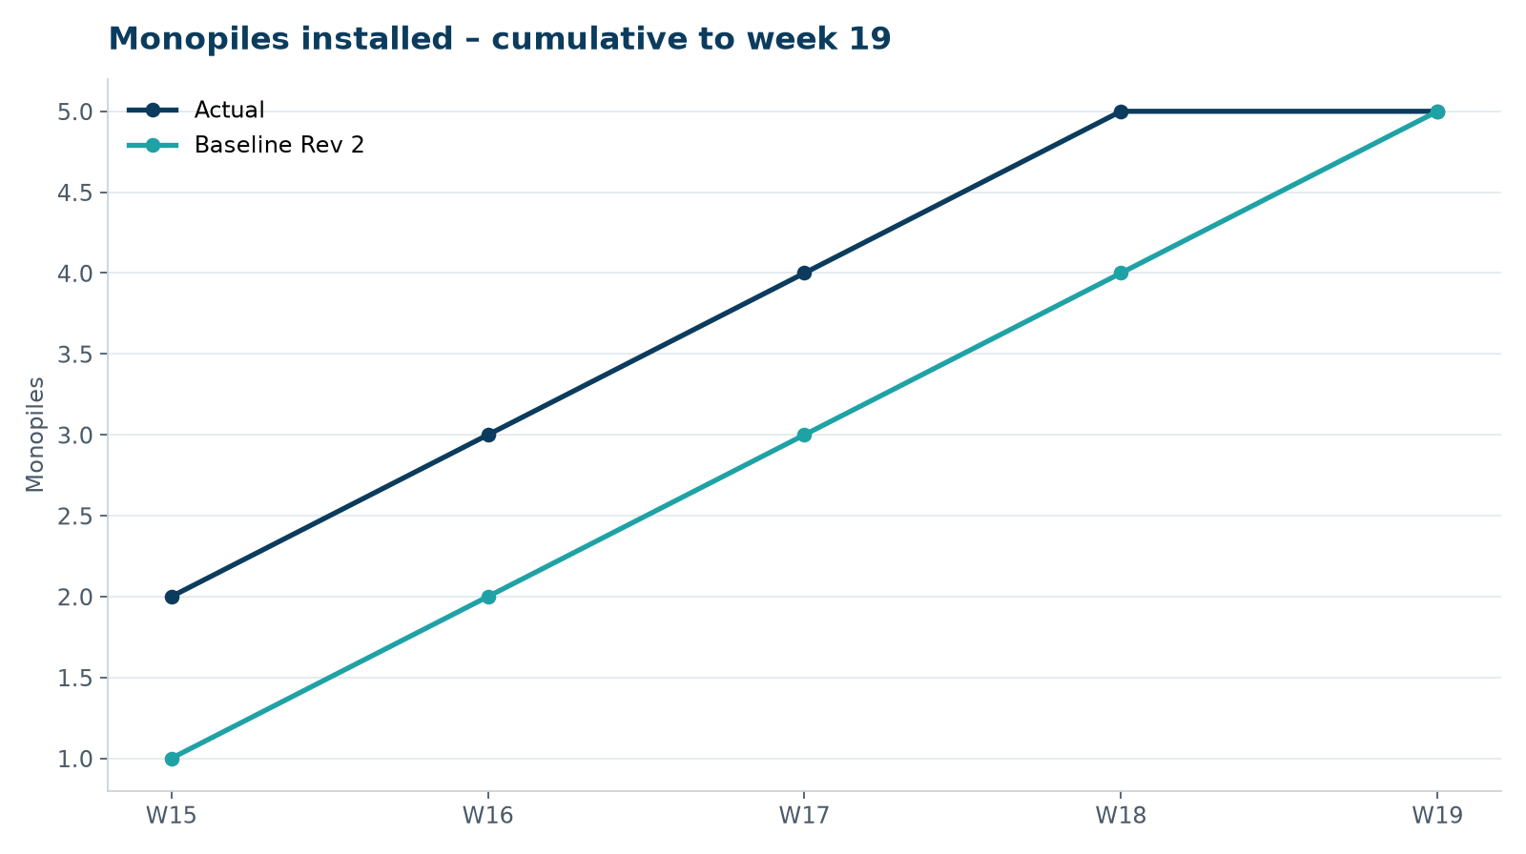
Figure 1 – Monopile installation progress, W15 to W19

3. Key activities this week
- No monopile installed: 52 hours waiting on weather (gale on 6–7 May).
- Transition piece HB-A05 installed and bolt tensioning completed.
- Rhenus Steelworks delivered monopile batch 3 (six piles) to the Port of Eastholm; receiving inspection found one coating defect, repaired on the quay.

4. Health and safety
No lost time injuries. 15 observation cards submitted; top theme: hot work permits.

5. Environment
- No piling this week; passive acoustic monitoring stations HB-PAM-01 to -04 operational.

6. Issues and risks
- HB-RISK-001 weather: 52 h downtime this week.

7. Look-ahead next week
Install HB-A06; TP HB-A05.
Prepared by Project Controls (Gareth Lewis); approved by Elena Márquez. Distribution: project team, Steering Committee, Halden Turbine Systems, Lenders' Technical Adviser.

